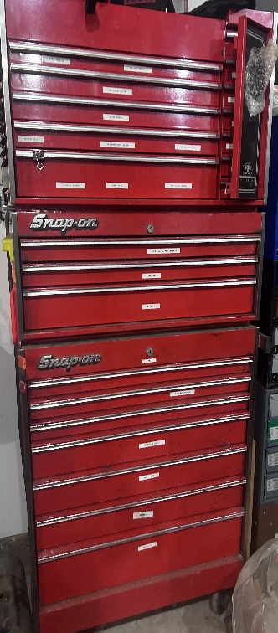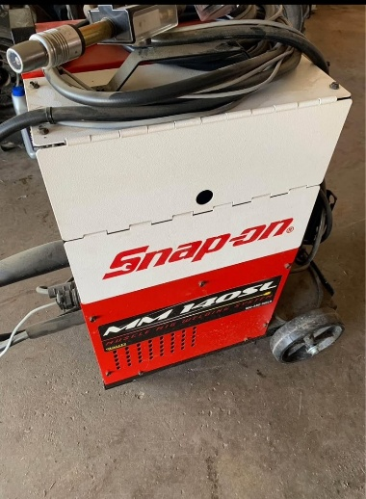***LIVE LARGE PUBLIC AUCTION***

Saturday June 28th 2025

***Starting @ 9:00am***

*14130 Lisbon Center Newark IL 60541*

Take IL Rt 71 to Newark go south on East Street to Lisbon Center Rd than east to farm yard. (watch for Signs)

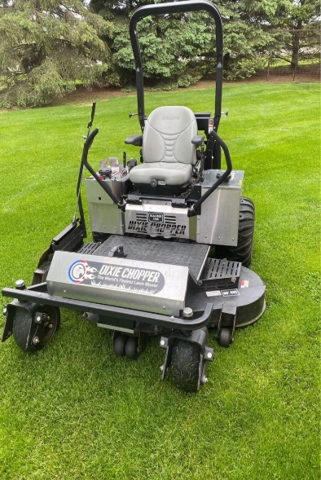***LARGE SELECTION OF SNAP-ON TOOLS & OTHER BRAND NAMES, SNAP ON TOOL BOXES-MIG TIG & ALU WELDER, SHOP EQUIPMENT-BRAND NAME POWER TOOLS, HOUSEHOLD FURNITURE & MID-CENTURY FURNISHING- LAWN TRACTORS & POWER EQUIPMENT, COLLECTIBLE ANITIQUE FARM RELATED ITMES***

***DIXIE CHOPPER XCALIBER 3366 ZERO TURN LAWN TRACTOR WITH ROLLBAR 436 hrs***

***This auction will feature something for everyone so bring a friend! Two auction rings running simultaneously*,** other interesting items includes a large Book collection ranging in themes several on history, war, & photography. Remote control helicopter, Cub Cadet 1810 Graden tractor with Kwik way loader & other garden tractors, chain saws & cut off saws, Milwaukee, precision tools, & wood chest, wood working tools power & hand, other lawn & garden power tools Totem Pole, Camera accessories, large quantity of hardware & hardware cabinets, Stihl power tools, cast iron Griswold antique tools, stoneware crock, yard bell, milk can, many other collectible and useful items too numerous to mention

***Terms*:** Cash, good check, Credit & Debit cards. Must have proper photo Id to register. All Items selling to best and highest bidder. No property removed until settled for prior to removing from property. Not responsible for items or accidents once sold, all sales are final. NO ITEMS OFFERRED ONLINE. ***NO BUYERS PREMIUM***, Plan to attend

**PROPERTY OF THE LATE PAUL & MARY KELLER, ESTATE**

***AUCTIONEERS:***

*Chris Wegener (815)-451-2820, Sandwich IL., Joel Prestegaard, Lee IL & Brian DeBolt Plano IL*

***For photos & more details www.Go2wegenerauctions.com***